2025 IIE Startups- 1/5/10 year:
Student Startups -Early Stage (1 year) | 505 
Student Startups -Incorporated (1 year) | 68
Incorporated Startups Alumni (1 year) | 70
Total Incorporated startups (5 year) | 688
Total Incorporated startups (10 year) | 1091
Total Incorporated still active (10 year) | 727
Total Venture Funding (10 year) | $352,927,613
Total Combined Estimated Valuation (10 yr.) | $946,670,000
Includes participation in accelerators, BIC, L&L, Startup Launch I,II
Startup data by year: | 2024-25 | 2023-24 | 2022-23 | 3-Year Total
Student Early Stage Startups  (Approximated) | 505 | 195 | 180 | 880
Incorporated Startups (Students) | 68 | 75 | 52 | 195
Incorporated Startups (Alumni) | 70 | 95 | 129 | 294
Total Incorporated Startups | 138 | 170 | 181 | 489
Startups still active | 129 | 138 | 131 | 398
Total Venture Funding | $ 24,444,200 | $ 10,335,200 | $ 183,383,000* | $ 218,162,400
Total Combined Estimated Valuation | $ 70,000,000 | $ 51,000,000 | $ 407,920,000 | $ 528,920,000
*Includes Heart and Vascular Partners: $180M (2022)

2015-2025 Startup Founders by School
School | Count | Founder Share %
Management | 388 | 38.80%
ECS | 284 | 30.80%
Natural Sciences & Mathematics | 78 | 8.20%
Bass School | 34 | 3.60%
Behavioral & Brain Sciences | 38 | 4.00%
Other | 138 | 14.60%

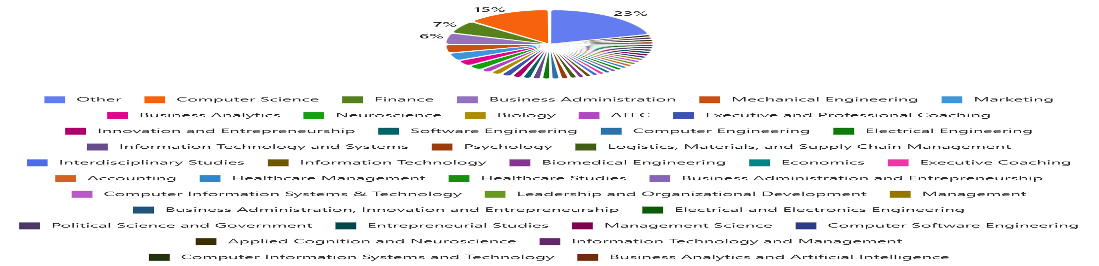
10 Year View of Startups by degree

2025 Startups by Degree
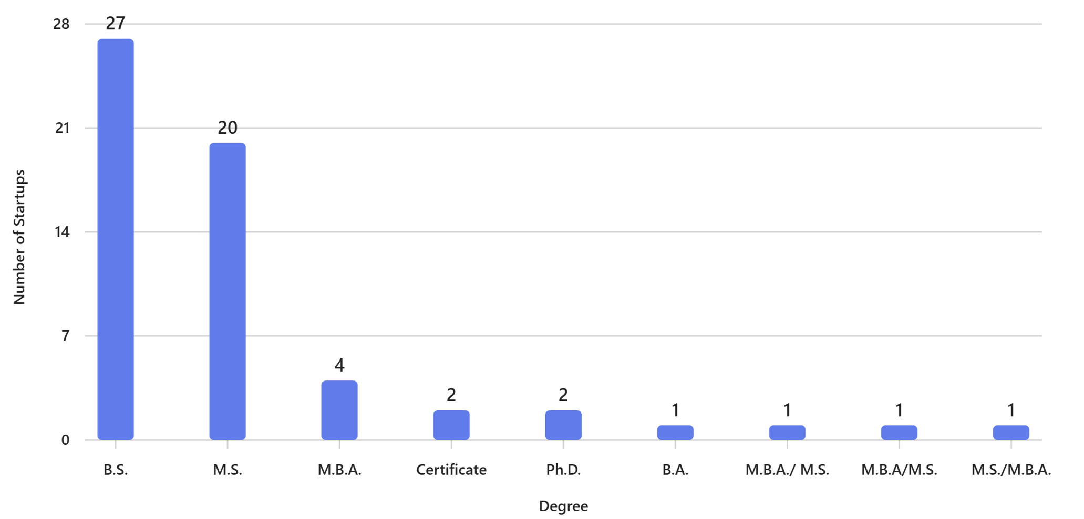

2025
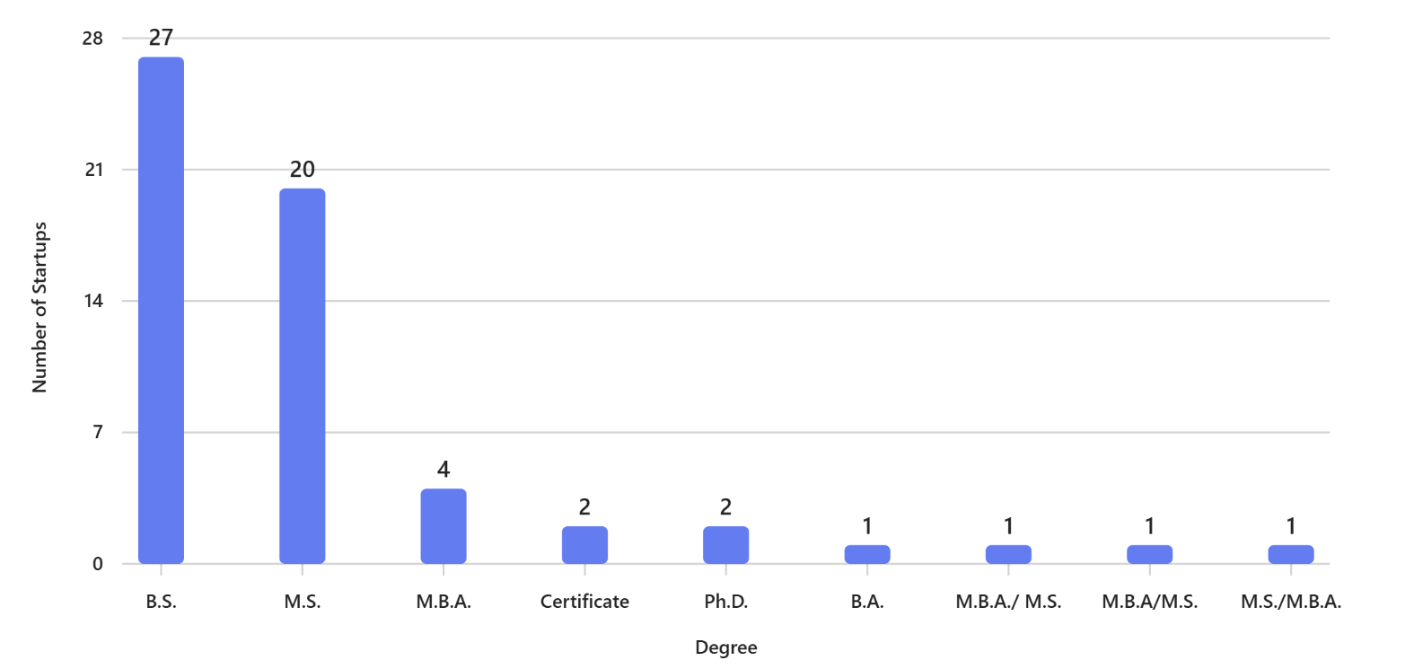
Pre-enrollment Students with Startups by Degree:
Startups Benchmarking to Top Universities: (2024-2025 Princeton Review reporting)


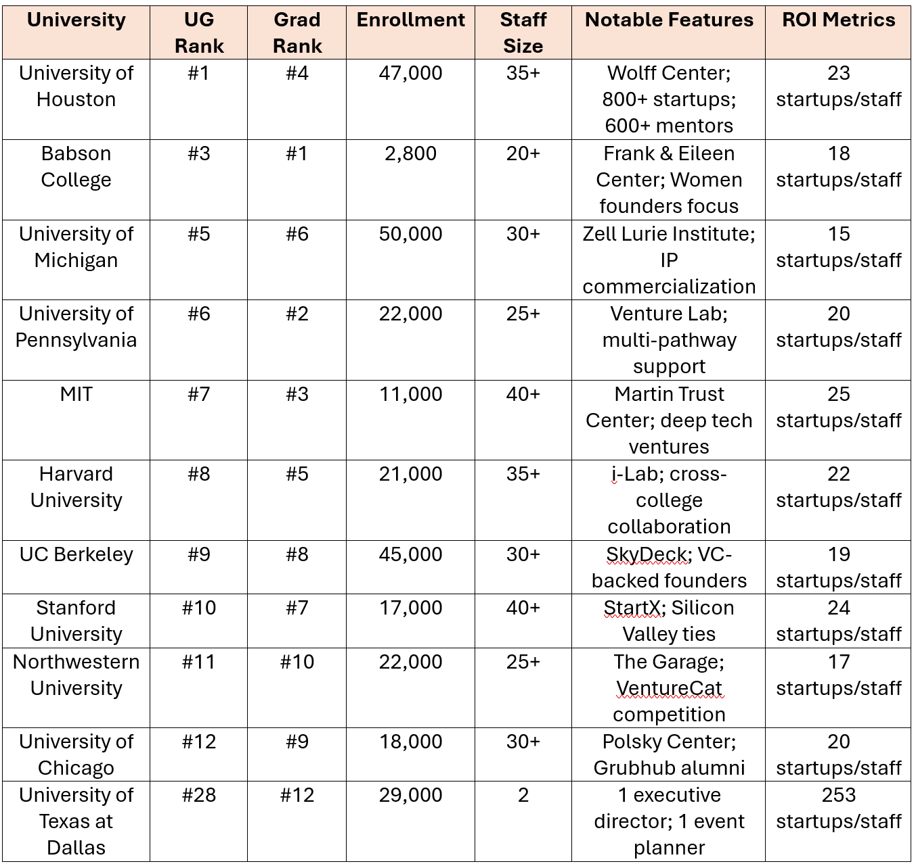
Startups Benchmarking By Ranking and Staff Size:

Top 5 Funded Companies (10 years):
- *Heart and Vascular Partners: $180M (2022) – Active
HVP increases delivers value to its physician partners through delivering a) scaled support services and business office functions, and b) resources, capital, and experience in accelerating the growth of cardiovascular practices.
- Hermtac: $45M (2020) – Active
Internet XaaS, Connectivity programs to boost your mission. We keep our partners connected so they can deliver care from the battlefield to the home.
- Rillet: $38.6M (2017) - Exited ’21
Rillet is the AI-native ERP automating accounting for complex revenue models, multi-entity setups, closing your books in hours and offering a source of truth for both GAAP financials and investor metrics.
- Integration Health: $16M (2025) – Active
We are a multi-disciplinary team that provides assessment and treatment services to individuals of all ages. Services include psychological assessments, counselling, ABA/IBI therapy, group programs, parent support, speech and language therapy, and naturopathic medicine.
- CV Staff Solution: $10M (2014) - Exited ’20
Search, outsource and placement firm specializing in Accounting, HR, Data Analytics

Key Metrics (10 years):
- Total funding raised: $352.3 million
- Average funding per company: $4.19 million
- Median funding: $225,000
-Highest valuation: Heart and Vascular Partners (HVP) founded by Dr. John Mehall: $400M

IIE Programming:
 | # Participants
Program: | 2025 | 2024 | 2023
Big Idea Competition | 125 | 40 | 34
Side Hustle Accelerator I | 156 | 0 | 0
Side Hustle Accelerator II | 57 | 0 | 0
Comet X | 68 | 22 | 23
Mentor Connect Network | 87 | 20 | 12
Lunch & Learns (will host 6 in 2025) | 90  (2 weeks) | 68  (4 weeks) | 92  (4 weeks)

2025-2026 IIE Programming Schedule:

UTD IIE & Startup Runway Collaborative Programming:
Date Time Program Details
Oct. 20 4-6pm Angel/VC Meet up @IQ
Oct. 27 8am-10am MOU signing event @IQ

Monthly Pitch Sessions w/ Startup Runway @ IQ:
Nov. 3 3-5pm Pitch to Angel/VCs UTD students/alums invited to pitch
Jan. 26 3-5pm Pitch to Angel/VCs UTD students/alums invited to pitch
Feb. 23 3-5pm Pitch to Angel/VCs UTD students/alums invited to pitch
Mar. 30 3-5pm Pitch to Angel/VCs UTD students/alums invited to pitch
Apr. 27 3-5pm Pitch to Angel/VCs UTD students/alums invited to pitch

Lunch & Learns
Sept. 8 12-1pm Startup Ideation JSOM Atrium, lunch served
Sept. 22 12-1pm Winning Pitch Competitions JSOM Atrium, lunch served
Oct. 6 12-1pm Validating your Concept JSOM Atrium, lunch served
Oct. 20 12-1pm Pitch deck tips & tricks JSOM Atrium, lunch served
Nov. 3 12-1pm Presenting like a pro JSOM Atrium, lunch served
Nov. 17 12-1pm Networking Mastery JSOM Atrium, lunch served
Spring Semester continuation… to be scheduled

NexGen Showcase:
Oct. 15 9:30-11:30am Startup Table tops Activity Center Atrium
1:30-3:30pm Startup Table tops Activity Center Atrium
3:30-4:00pm Award ceremony Activity Center Atrium

Big Idea Competition:
Dec. 1 Applications open online StartupTree
Jan. 22 midnight Applications close StartupTree
Jan. 23 – Feb. 4 Expert online reviews StartupTree
Feb. 6 3-6pm Judging Roundtable JSOM conference room
Feb. 25 3-6pm Preliminary Pitch ( < 50) 3 rooms- Exec Ed
Mar. 25 9am-12pm Semi-Finals (12 stud., 6 alum) Exec. Ed, various rooms
Mar 30-Apr.10 TBD Building stage presence ATC Lecture Hall
April 15 5-8pm Finals (3: UG, G, A) ATC Lecture Hall

Hult $1M Prize International Competition: (Between Sept-Feb teams of 2-4)
TBD Applications open online HULT
TBD Applications closed online HULT
TBD Review of applications Online review
TBD Final presentations announced
Nov.15? or late Jan? UTD Campus Qualifier Final ATC Lecture Hall
April-May Nationals @HULT

Other:
May-June Side Hustle I Accelerator Online
July-Aug. CometX Accelerator Exec. Ed
Sept-Nov. Side Hustle II Accelerator Online
Sept. 30 PEP (Prisoner Entp. Prog.) Pitch Competition Davidson Auditorium

